Map ID | Location | Number of Steps | Average Step height | Total Height
A | Wendigo Way to Bloor St W | 77 | 3 @ 15 cm, Rd 74 @ 17 cm | 1303
B | Valleymede Rd to Palisades | 99 | 17@ 13 cm, 72 @ 17 cm | 1445
C | Upper Rennie Park East between 250 & 252 Ellis Ave | 47 | 47 @ 12 cm | 564
D | Lower Rennie Park (between 208 & 222 Ellis Ave | 75 | 75 @ 15 cm | 1125
E | Catfish Pond | 35 | 35@ 10 cm | 350
F | Beside Rennie Park Club House | 15 | 15 @ 18 cm | 270
G | Rennie Terrace to Rennie Park West | 23 | 23 @ 15 cm | 345
H | Swansea School Grounds to Playing Field | 31 | 31 @ 10 cm | 310
I | Swansea School south to St Olaves Rd | 3 | 3 @ 14 cm | 42
J | Budgell Terrace to Ormskirk Park | 67 | 67@19 cm | 1273
K | Innisfree Court to Ormskirk Park | 19 | 19 @ 15 cm | 285
L | Windermere to Southport | 81 | 81 @ 15 cm | 1215
L2 | Windermere Ave to West Windermere Arm | 4 | 4 @ 14 cm | 56
M | Easson Ave to Morningside Ave | 17 | 11 cm | 187
N | Morningside Ave to Riverside Drive | 62 | 13 cm | 806
O | Riverside Crescent to Riverside Drive (Lucy Maude Montgomery Park) | 42 | 15 cm | 630
P | Riverside Trail between Riverside Drive and Brule Gardens | 14 | 10 cm | 140
Q | Willard Gardens to Yule Ave | 61 | 61 @ 15 cm | 915
R | Deforest Road through Upper Willard Gardens Parkette | 3 | 3 @ 18 cm | 54
S | Mayfield Ave to Willard Gardens Parkette | 48 | 48 @ 15 cm | 720
 | Total | 823 |  | 12035 cm
 |  |  |  | 120.035 m
Stepping out in Swansea
The topography of Swansea includes multiple ridges and ravines mostly carved long ago by water and glaciers. To aid walking across this hilly terrain, a number of stairways can be found across our community. Here is a list of these:

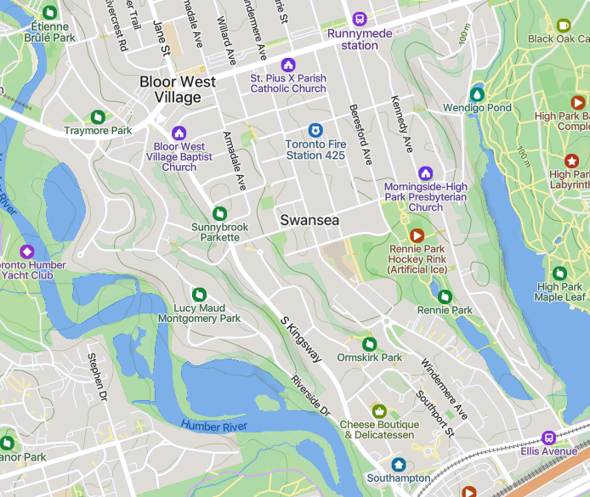
C
D3
M
N
P
R
S
Q
O
L
K
JJ00
I9
F
H
G
E4
B2
A

