Swansea and Surrounding Area Commemorative Plaques, Sculpture and Historic Signs
Name | Year(s) Commemorating | Location | Picture
The STELCO Swansea Works | 1882 - 1990 | East off Queensway West ramp to South Kingsway | 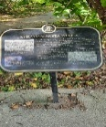
The Canoe & Calipers | 2006 | SE corner of Queensway and Windemere | 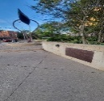
The Ballad of Ice and Water | Evolution of water in the area over last 15,000 Years | SW corner of Queensway and Windemere | 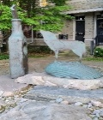
Jean Baptiste Rousseaux Historical Marker | 1791 | Off South Kingsway west side just south of Petro Canada Car Wash | 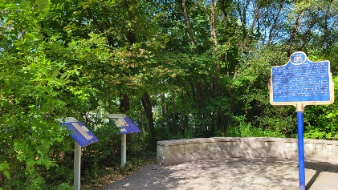
The Beginnings of French Toronto | 1660 - 1759 | Off South Kingsway west side just south of Petro Canada Car Wash | 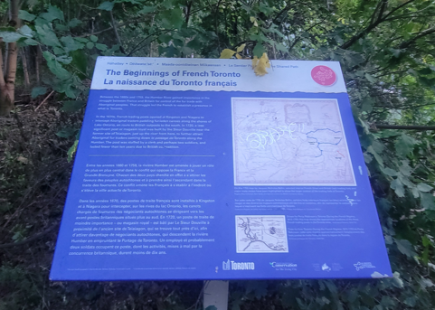
The Rousseaux Family and Early Toronto | 1770 - 1795 | Off South Kingsway west side just south of Petro Canada Car Wash | 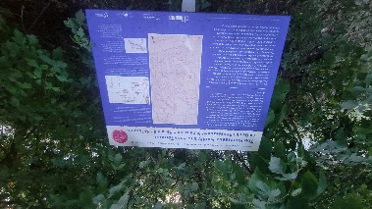
The Toronto Carrying Place Trail | 1615 | This trail has multiple signs acknowledging its historical significance along the Humber River. Though route passes through Swansea, there are no signs until north of Bloor. | 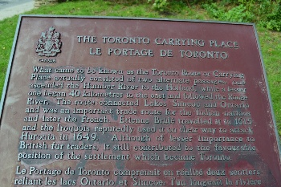
Lucy Maud Montgomery | 1935 - 1942 | North end of Lucy Maud Montgomery Park, Riverside Drive | 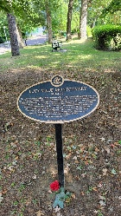
Painting (faded) of Carrying Place Trail | Painted originally in 1984 by local high school students  commissioned by City | West side of South Kingsway north of Ripley west side just south | 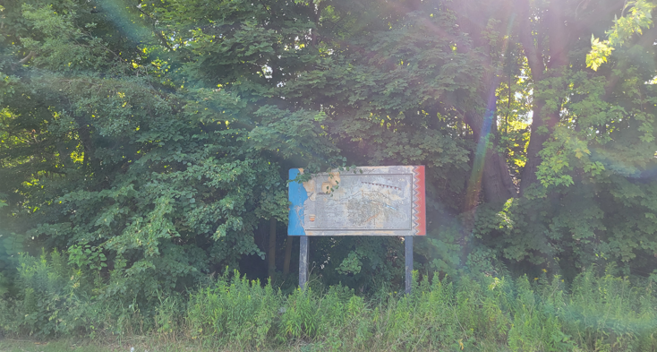
Painting (faded) of Humber River | Painted originally in 1984 by local high school students  commissioned by City | Off South Kingsway west side just south | 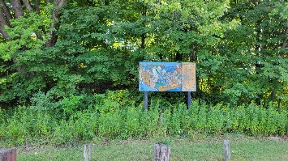
Painting (faded) of Carrying Place Trail | Painted originally in 1984 by local high school students  commissioned by City | Off South Kingsway west side just south | 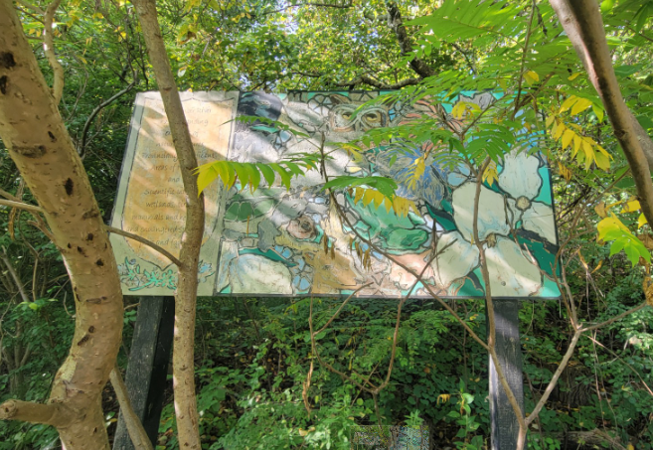
Runnymede Theatre | 1927 | On Bloor West, outside entrance to Shopper’s Drug Mart | 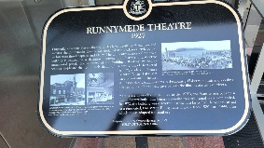
Bloor West Village BIA | 1970 | Runnymede Road west side in park north of Bloor across from Subway Station | 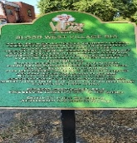
The Souster Steps | 1921 - 2012 | Bottom of Stairs Willard Gardens Parkette | 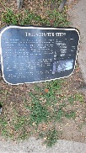
Swansea Centennial Project Improving Rennie Park | 1967 | Rennie Park East edge just south of Morningside | 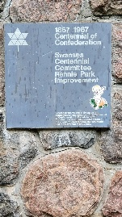
The Alex Ling Fountain | 2005 | NW Corner of Jane and Bloor West | 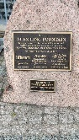
David H Williams Clubhouse | 1989 | Rennie Park Clubhouse upper floor entrance | 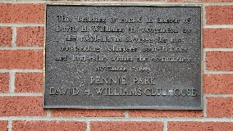
Corporal Filip Konowal | 1917 | Ukrainian Credit Union, Boor West @ Armadale | 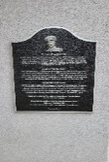
Canada’s first national internment operations of 1914 – 1920  “Without Just Cause” | 1914 - 1920 | Ukrainian Credit Union, Boor West @ Armadale | 